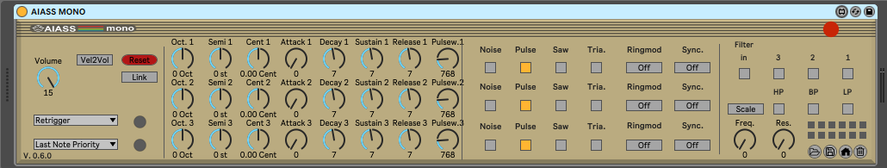
AIASS - SIDBlaster Control Plugin for Ableton Live

Programming and UI design by Andreas Schumm
Copyright © 2022
www.crazy-midi.de
English manual by Magnus Hansson, version 1.5
Index

Hardware installation 3
Voltage Jumper settings on the SIDBlaster hardware 5
Other Jumpers on the hardware 6
USB and audio connections 7
General information 8
Software installation 9
AIASS Mono Version 11
Mono Master section 12
Oscillator pitch section 15
ADSR envelope and Pulse Width 17
Waveforms and Noise 18
Filter and Preset section 20
AIASS Poly version 25
Poly Master section 26
AIASS Flow versions 28
Tips 31
Links 36
Thanks to 37

Hardware installation

SID-chip installation
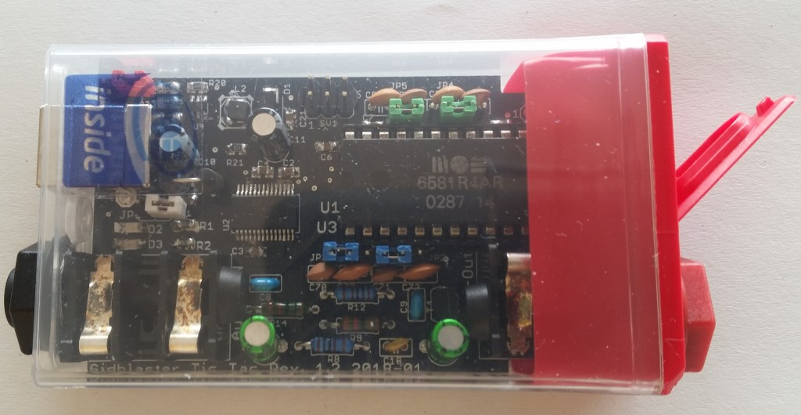
SIDBlaster Tic Tac version with a 6581 SID-chip correctly installed.
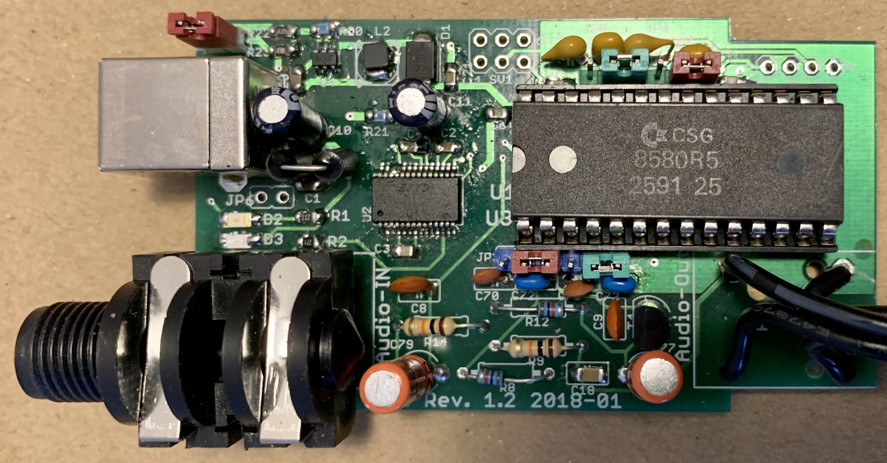
SIDBlaster with an 8580 SID-chip correctly installed.

Voltage Jumper settings on the SIDBlaster hardware
For the 6581 SID-chip - J1 must be open (12V). Place all jumpers on the left side (pins 1-2).
For the 8580 SID-chip - J1 must be closed (9V). Place all jumpers on the right side (pins 2-3).

Warning! Double check the voltage settings on the SIDBlaster hardware. If you set them incorrectly, for example sending 12V into an 8580 SID-chip which runs at 9V, you will destroy the chip. If you have a multimeter, check the voltage at the SID chip socket to be sure.
Always use an anti static bracelet to avoid damaging the SID-chip and other electrical components when installing it in the SIDBlaster.
Other jumpers on the hardware
JP2 & JP3 (blue) are for switching the filter capacitors.
JP4 & JP5 (green) are for the optional paddle capacitors.
JP6 (White) From Rev. 1.2 and on. Experimental, connects USB shield to ground; you may try it to counteract interfering noise.
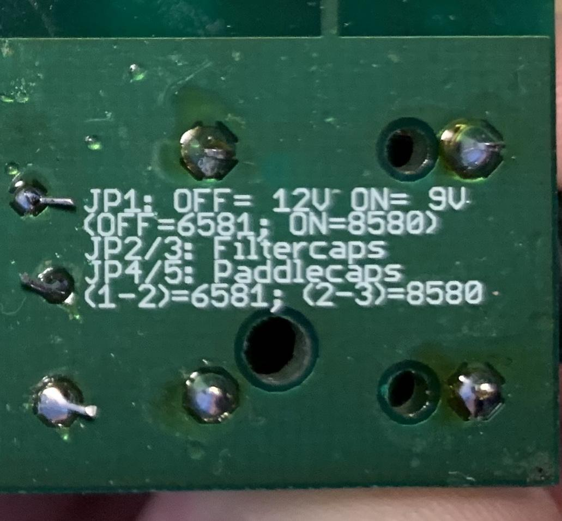
Text on reverse side of SIDBlaster PCB with jumper settings.
USB and audio connections
Connect the SIDBlaster hardware to a USB port using a type A-B USB cable of good quality. It can also work with a good quality USB-hub.

The SIDBlaster needs to do a digital "handshake" the first time it is connected via USB. This requires an internet connection. The handshake will not work if your internet connection is set to “Metered Connection” in Windows. To solve this, temporarily disable “Metered Connection”, wait a moment for the SIDBlaster to do the handshake, and then re-enable “Metered Connection”.

Connect the audio output of the SIDBlaster to your mixer or audio interface using an unbalanced (mono) cable. The second audio jack on the SIDBlaster is an audio input and is also an unbalanced connection. If you are unsure which connector is which, the connectors are marked on the PCB. Be careful about what you connect to the input of the SID-chip. These chips are old and very sensitive to electrical spikes and too high voltages.

General information
Plug and play is not possible, the SIDBlaster must be plugged
in before starting Ableton Live

When you are not using the SIDBlaster it is recommended to unplug the USB-connection since this prolongs the life of the SID-chip.

Since a SID-chip produces heat, use a heatsink on the chip if possible and make sure there is sufficient ventilation.
Software installation
-Copy the SID-object folder and all its content to:
Documents/Max8/packages/
-Copy the devices to any place of your ableton live user-library.
Depending on whether you work with a Mac or PC, the following steps are necessary to install the FTDI D2XX driver and the hardssid library:
Windows:
The SIDBlaster is recognised by Windows as a “USB Serial Converter”.
With older versions of Windows, installation of a driver by FTDI may be necessary, available at:
http://www.ftdichip.com/Drivers/D2XX.htm
Copy the 64 bit version of hardsid.dll to C:\Program Files\Common Files\VST3\

MacOS
Proceed in the following order:
1.: Download and install the D2XX driver from FTDI
http://www.ftdichip.com/Drivers/D2XX.htm (see readme from FTDI)
2.: Download and install the FTDI Helper Tool from FTDI.
3.: Copy the libhardsid.dylib to /usr/local/lib/

AIASS Mono version

Mono Master section:
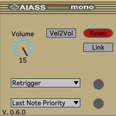

Volume = Master volume. To get the best possible signal to noise ratio, it is best to leave it a 15.
Vel2Vol = When activated velocity will control Master volume.
Reset = Double click resets AIASS to its default setting. Warning! All unsaved settings will be lost when pressing "Reset/Init".
Play Mode =
- Retrigger - Notes are retriggered every time a key is pressed, but if more than one key is held, the note will return to its previous pitch after the second key is released,
- Legato - Notes are played Legato, i.e. the pitch "glides" between notes.
- Last step - Notes are retriggered every time a key is pressed, and if more than one key is held the previous note will be cut off.
Note mode =
- Last Note priority prioritises the last Midi note when several notes are pressed.
- High Note priority prioritises the highest Midi note when several notes are pressed.

- Low Note priority prioritises the lowest Midi note when several notes are pressed.

Link = Links the controls for oscillator tuning, ADSR and Pulse Width, which is helpful when adjusting the sound for all oscillators at the same time. If unchecked, all controls are edited one by one.
Activity LEDs = Indicates notes on and off. When clicked on, the green LED can also “hold” a note, e.g. when adjusting the pitch of the Oscillator.
Oscillator and envelope section:
There are 3 oscillators on a SID chip, each with its own ADSR envelope hardwired to the VCA (Voltage Controlled Amplifier), i.e. creating a volume envelope. The filter is not connected to an envelope on the SID chip by design.
However, there are ways around this as described in the tips section.
Oscillator Pitch section
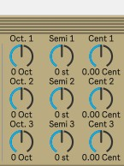
The oscillator pitch can be changed using the:
Oct = Changes the oscillator pitch up or down in one octave steps
Semi = Changes the oscillator pitch up or down in semitone steps
Cent = Fine tunes the oscillator pitch
ADSR envelope and Pulse Width
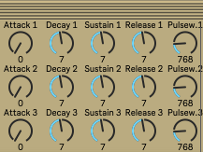

ADSR = As mentioned above, each oscillator has its own ADSR envelope. It allows control of the Attack, Decay, Sustain and Release time of each oscillator's VCA (Volume envelope).
Pulsew. = This controls the Pulse Width for each oscillator. It is particularly useful when using the Pulse waveform.
Waveforms and Noise
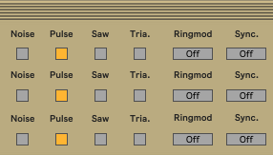

Each oscillator has three waveforms, Pulse, Saw and Triangle, plus Noise. Several waveforms can be selected at the same time. However, the noise can not be combined with the other waveforms.

Ringmod = Ring modulation
This effect is only audible when the Triangle wave is activated.

Ringmod.1 Activates the Ring Modulation on Voice 1.
The Oscillator must be set to Triangle Wave.
It is a ring modulation of voice 1 and voice 3.

Ringmod.2 Activates the Ring Modulation on Voice 2.
The Oscillator must be set to Triangle Wave.
It is a ring modulation of voice 2 and voice 1.

Ringmod.3 Activates the Ring Modulation on Voice 3.
The Oscillator must be set to Triangle Wave.
It is a ring modulation of voice 3 and voice 2.

Sync. = Synchronizes the Oscillators to each other.
Sync. 1 Activates the Oscillator Sync on Voice 1. This syncs Voice 1 with Voice 3. The frequency of Voice 3 must be lower than Voice 1 for it to have any audible effect.

Sync. 2 Activates the Oscillator Sync on Voice 2. This syncs Voice 2 with Voice 1. The frequency of Voice 1 must be lower than Voice 2 for it to have any audible effect.

Sync. 3 Activates the Oscillator Sync on Voice 3. This syncs Voice 3 with Voice 2. The frequency of Voice 2 must be lower than Voice 3 for it to have any audible effect

Filter and Preset section

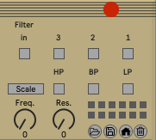

Filter section
In = There is an option to activate the filter for the external input. This will raise the noise level since the input of a SID-chip is quite noisy by design. Actually, the SID-chip is pretty noisy, but that’s also part of the charm. As mentioned above, please be careful about what you connect to the input of the SID-chip. SID-chips are old and very sensitive to electrical spikes and too high voltages.
Filter activation buttons = The filter is activated for each oscillator separately (oscillator 1-3).
Scale button = There are two main types of SID-chip, the 6581-version and the newer 8580-version. The main difference is the filter. The 8580-version has an updated filter where the resonance control is more effective. The cutoff characteristics are also different between the two chips. The two modes of this button sets the cutoff scale for the 8580 and 6581 respectively. Try both scales, it might sound nice.
Filter types =
LP = Low Pass
BP = Band Pass
HP = High Pass
All filter types can be freely combined.
Freq. = Changes the filter Cutoff Frequency for all oscillators which have their filter activated.
Res. = Changes the Resonance amount for all oscillators which have their filter activated.

Preset section
There are twelve buttons located in the lower right corner of AIASS. Each button is a preset slot.
AIASS comes with two factory banks of sounds. One for the AIASS Mono/Mono Flow (mono sounds) and one for the AIASS Poly/Poly Flow (poly sounds).

To save a preset: Hold shift + click on a preset slot button.
To load a preset: Double click on a preset slot button.
To load a preset bank = click on the “Folder” icon in the lower right hand corner of AIASS.
To save a preset bank = click on the “Floppy Disk” icon in the lower right hand corner of AIASS.
When using the AIASS Flow versions, which are described in detail below, make sure that presets are loaded from the Master-device in the chain and that the “Master” button is activated on the first instance of AIASS, to make sure all devices load the preset. The same applies when loading preset banks.
Clicking the House icon loads the factory presets.
Clicking the Trashcan icon deletes all presets in the current bank.

Power LED =

If the Power LED flashes at a rate of 125ms, the SID-object has not been found.

If the Power LED flashes at a rate of 250ms, an error in the SID-object has been detected. This could mean that the .dll file is not found or that the computer can not find the SIDBlaster hardware.

The Max Console can be opened by clicking on the first of the three buttons in the upper right corner of AIASS.

AIASS Poly version
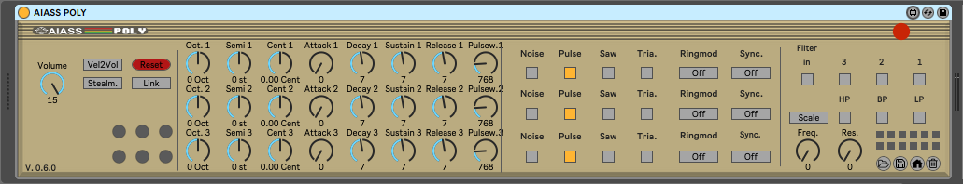
Since the SID-chip has three oscillators, it is possible to use it in Poly mode (Paraphonic to be exact, because all oscillators go through the same filter) and be able to play three simultaneous notes. To use SIDBlaster in Poly mode, load the AIASS Poly instrument in Ableton Live.
The Poly instrument looks and functions the same as the Mono version, except for the Master section.

Poly Master section
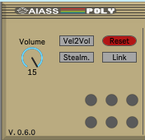

Incoming Midi notes are “rotated”. The first note triggers oscillator 1, the second note triggers oscillator 2 and the third note triggers oscillator 3, after that, the fourth note triggers oscillator 1 again and so on.
Stealm. = Steal Mode that cuts off old notes as new are played.
Link = Links the controls for oscillator tuning, ADSR and Pulse Width, which is helpful when adjusting the sound for all oscillators at the same time. If unchecked, all controls are edited one by one.
Volume, Vel2Vol, Reset and the Activity LEDs have the same function as in the Mono version.

AIASS Flow versions
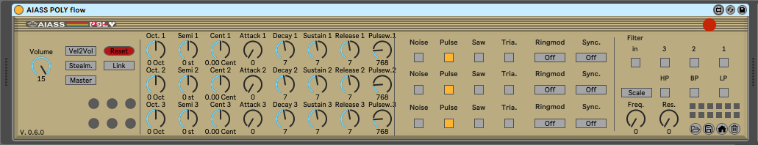
It is also possible to link several SIDBlasters. Up to eight SIDBlasters can be connected for 8 note full polyphony or 24 voice paraphony depending on which Flow device you use.
You need to connect the additional SIDBlasters via USB directly, no USB hubs please, since they can cause problems. Then load two (or more) instances of AIASS Flow on the same midi channel in Ableton.
The first AIASS instance always has to be set to “Master”. The button is located on the left hand side in the AIASS Master-section.
This way the second instance automatically follows all parameter settings on the first instance. Please make sure that the devices are “neighbours” on the midi channel, i.e. no other devices in between.
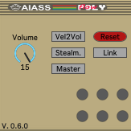
AIASS Flow Master section

Example:
If you have two SIDBlasters, connect both via USB, make sure they have done their digital handshake as mentioned earlier in the manual if it is the first time they are connected to the computer, and then load two AIASS Flow instances in Ableton. Set the first device to “Master”, and that’s it.
The same procedure applies when connecting three or four SIDBlasters.
There are two different Flow versions, AIASS Mono Flow and AIASS Poly flow.
When using the AIASS Mono Flow device and linking several SIDBlasters you will get a true polyphonic synth. Each SIDBlaster represents one voice with three oscillators each. With four SIDBlasters connected you get a four voice, twelve oscillator synth.
When using the AIASS Poly Flow device you get three voice paraphony per SIDBLaster, i.e. four chained SIDBlasters gets you 12 voices with one oscillator per voice.

Tips
- Add as many LFO’s as you want to SIDBlaster with Midi LFO’s.
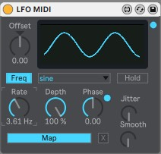
Download MAX for Live Essentials from Ableton's webpage. After installing the package, the Midi LFO is found under:
MAX for Live Essentials->Max Midi Effect->Control Devices MIDI
Click “Map” on the LFO and then click on the parameter you would like to control. You can add as many LFO’s as you like.
One classic example is to map the LFO to the Pulse Width of an oscillator and set the waveform to Pulse, in order to get some PWM.
- Add as many ADSR-envelopes as you want to SIDBlaster with Midi Envelopes.
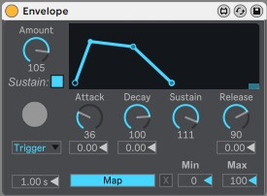
The Envelope is also included in MAX for Live Essentials. After installing the package, the Midi Envelope is found under:
MAX for Live Essentials->Max Midi Effect->Control Devices MIDI
Click “Map” on the Envelope and then click on the parameter you would like to control. Now, everytime a note is played, the Envelope is triggered. You can add as many Envelopes as you like.
One example would be to add an ADSR to AIASS Filter Cutoff parameter. This way you can control the envelope of the filter.

- Lower the AIASS the Decay and Sustain settings if you get internal distortion. The SID-chip distorts quite easily, especially when playing all oscillators at the same time.

- Try an Arpeggiator with a fast tempo on the Mono version of AIASS to get classic Commodore C64 arpeggiated "chords".

- You can map a Midi controller to any AIASS parameter, for example: Mod Wheel to Cutoff Frequency.

- If you put Ableton’s External Audio Effect after AIASS, you can route the audio output of the SIDBlaster to the same track in Ableton. “Audio out” routing in the External Audio Effect can be omitted.
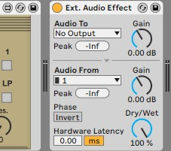
Links
https://github.com/gh0stless/AIASS-for-MAX4LIVE
http://crazy-midi.de/
https://www.ableton.com/en/packs/max-live-essentials/

Thanks to
Davey (The Phantom) for creating the SIDBlaster.
Wilfred Bos for tips and helping.
Stein Pedersen for assistance and the sidblaster.dll.
Rico Frenzel for help and testing.
Karl-Werner Riedel for his help with designing the TicTac hardware.
Magnus Hansson for ideas, testing, presets and writing this nice manual.
Borjana Konstantinowa for her patience with me.

-Andreas

